Corporal Melroy Cort USMC
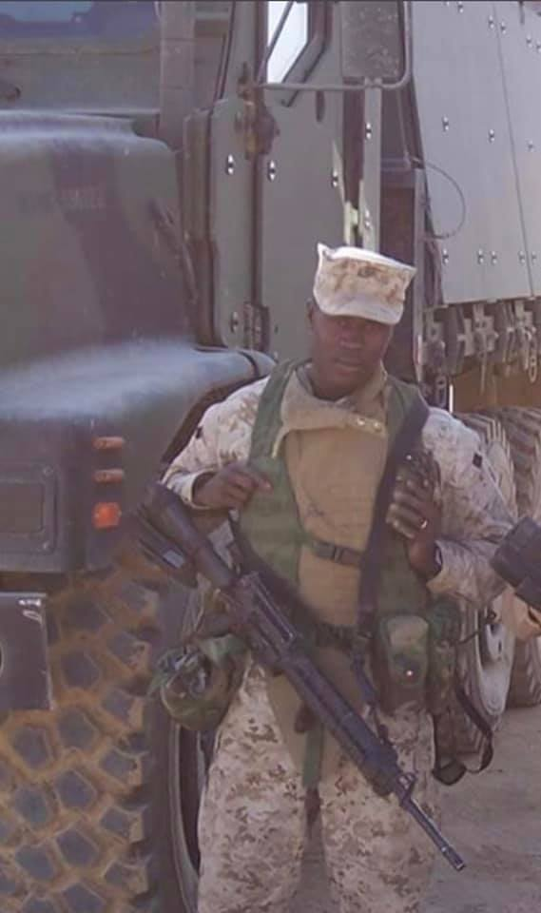
Born in Guyana, South America - Cpl. Melroy Cort would emigrate to Brooklyn New York with his parents, 3 brothers and 1 sister in 1994 at the age of 10. The family would eventually decide to leave behind the hustle and bustle of New York for the tranquil serenity of Columbus Ohio. Melroy would quickly adapt to his new life by attending Reynoldsburg High School where he would meet his high school sweetheart Samantha. Everything seemed perfect until the morning of September 11th 2001 , when the innocence of all Americans would be shattered on that fateful day. The shock of what was unfolding on the TV in Melroy`s classroom would quickly turn to fear for his older brother Matthew , who worked at the WTC complex In NYC. The feelings of desperation would change to joy upon finding out that Matthew was not at his desk at the time of the attacks, but that joy would fade to guilt as he realized that though he was blessed for the safety of his brother – thousands of families across our Country and many other Nations would be changed forever.
The memories of that day would influence Melroy’s decision that he needed to so something for his adopted Country, so at the age of 19 he swore an Oath to the United States and started his journey to become a U.S. Marine. He would report in May of 2004 and spend 13 weeks training in Platoon 2064, Hotel Company of the 3 Recruit Training Battalion at Parris Island, South Carolina then directly to Marine Combat Training at Camp Lejeune, North Carolina as a Tactical Vehicle Operator . From there, he would report to Hotel Company, 3rd Battalion, 7th Marines in Twentynine Palms , California
Melroy and Samantha would marry 4 months prior to the September 2005 deployment of the Battalion know as “ The Cutting Edge “ to Ramadi, Iraq in support of Operation Enduring Freedom. 3/7 would be tasked with providing security for Camp Snake Pit and the surrounding areas. His platoon would preform convoys and patrols designed to disrupt enemy movement and activities.
On December 7th his Platoon was on a extract mission to assist on the Med-Evac of injured Marines, the mission was diverted and they were on their way back to Camp Snake Pit when the lead Humvee struck the first IED. Cpl. Cort who was operating a 7 ton tactical vehicle at the time of the attacks, immediately started positioning his vehicle to support the wounded Marines ahead in the destroyed Humvee. Cpl.Melroy Cort and his squad would dismount the 7 ton tactical to provide a security perimeter and reach the wounded Marines when the second more powerful explosion occurred. The IED consisted of four 155MM High Explosive Projectile rounds , just one has a killing radius of 150 feet, the 7 ton Vehicle would take most of the impact of the massive blast but unfortunately not all of it. Cpl. Melroy Cort and 5 of his fellow Marines would be catastrophically wounded with one dying immediately from his wounds and the others receiving injuries that would forever change their lives. The injured Marines were rapidly evacuated to Camp Ramadi for lifesaving treatments. Cpl Cort would endure the amputation of both legs above this knees, permanent damage to his right hand, traumatic brain injury and PTSD. Once stabilized enough , Cpl Cort would be flown to Germany and then to Walter Reed Medical Facility to continue medical treatments for the next year and half.
In 2007 he would be medically discharged from the Marine Corps. That is when Melroy and Samantha would return to Columbus Ohio to start a family. They were blessed to have 9 children – 5 girls and 4 boys with 2 sets of twins. Life for the Cort`s was fantastic, but all this would change on May 28th 2018 when the family home and all their belongings were lost due to a electrical fire. They have been staying between hotels and family members until they can get life back to normal.
Now , The Stephen Siller Tunnel to Towers Foundation which was established in Honor of Stephen Siller a FDNY Firefighter who made the Ultimate Sacrifice on 9/11 , is working with A Soldier's Journey Home to build the Cort Family an ADA compliant mortgage free smart home in Columbus Ohio that will be constructed in 12 days starting on June 1st and completed on June 13th 2020.
